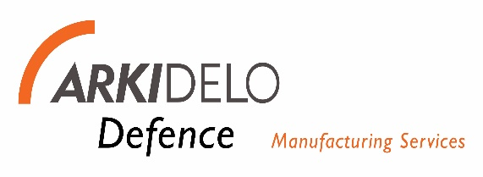

Quality Policy Statement

The quality and reliability of Arkidelo’s services are seen as paramount to the success and growth of our business.
Our Management Team is therefore committed to demonstrating leadership with respect to our quality management system and shall take accountability for the effectiveness of the system in ensuring applicable product and service requirements are met.
However, quality must continue to be the concern of every person in the Company, not just the sole responsibility of the Management Team. Every person in the Company has quality related responsibilities, and it must be accepted and understood that every aspect of what we do in the business ultimately affects the level of client satisfaction.
The Company is committed to establish quality objectives for relevant functions, levels and processes needed for the quality management system. All quality objectives shall be appropriate, measurable, and continuously reviewed and updated to ensure service conformity and enhance customer satisfaction.
Our Quality Management System shall be designed to ensure that we consistently provide services that meet customer, statutory and regulatory requirements and aim to enhance customer satisfaction through the effective application of the system.
The Quality Management System that the Company has established is based on compliance with the standard ISO9001:2015 Quality management systems — Requirements.
The systems, processes and methods employed within the system are to be kept under continual review and improved whenever and wherever possible.
These principles are basic to the Company and all employees are expected to embrace and support them as a team and to actively pursue the requirements of the Quality Management System so that we can meet the expectations of our clients.

Signed: Date:
Trevor Jack
Managing Director

